

**Mobile Application Development**

**MAD400-75 iOS Development**

**Assignment 1 Part II**

**Submitted by:**

**Pawan Pandey**

**Student id:**

**A00107427**

**Submitted to**

**Manhar Kapoor**

**Date:17-07-2021**

**Xcode**

Xcode is an IDE, integrated development environment, created by Apple for developing software for macOS, iOS, watchOS, and tvOS. Xcode includes all of the tools needed to create an app within one software package; namely, a text editor, a compiler, and a build system. Xcode integrates all the tools which are required. It is the only legitimate program you can use to make native Apple product applications. This robust interface takes composition of source code, to the process of debugging and even for designing of user interface and uploading to the App Store all within your window.

**Download and install**

* **the iOS app store**

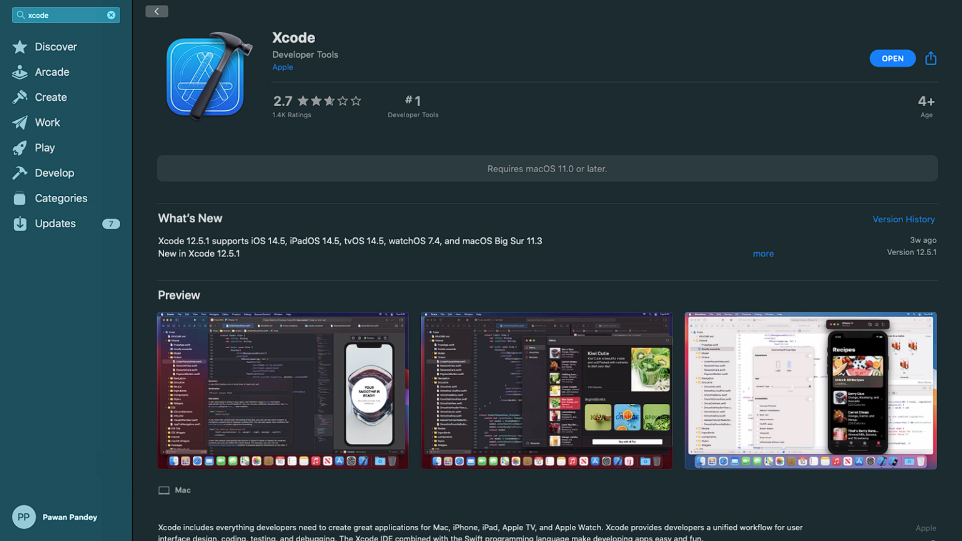

* **online apple’s developer website**

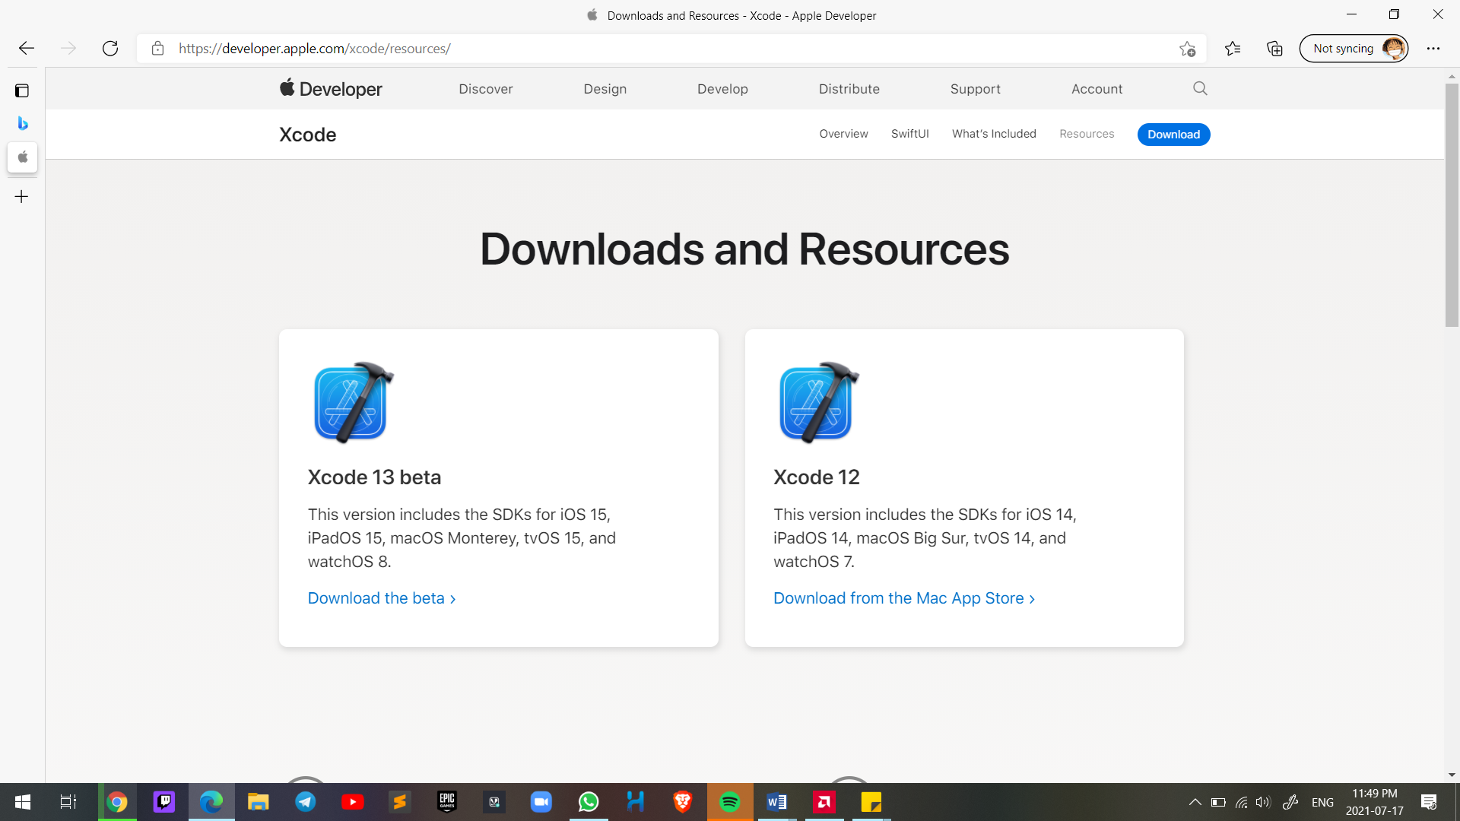

**Get started screen**

* Launch XCode, and Welcome to Xcode window will open,

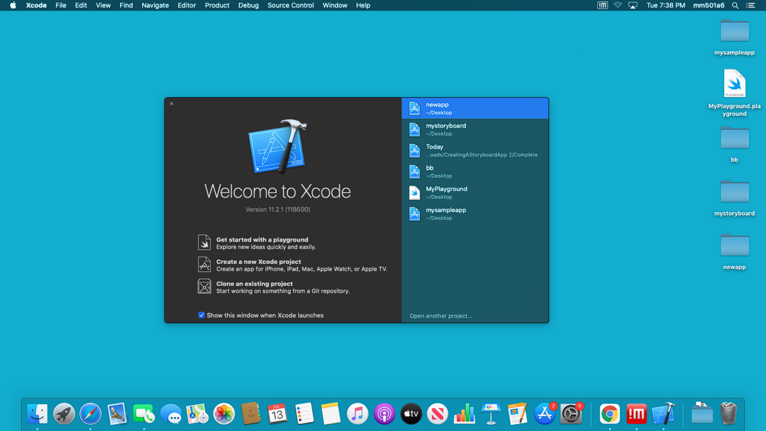

* **Select Create a new project**

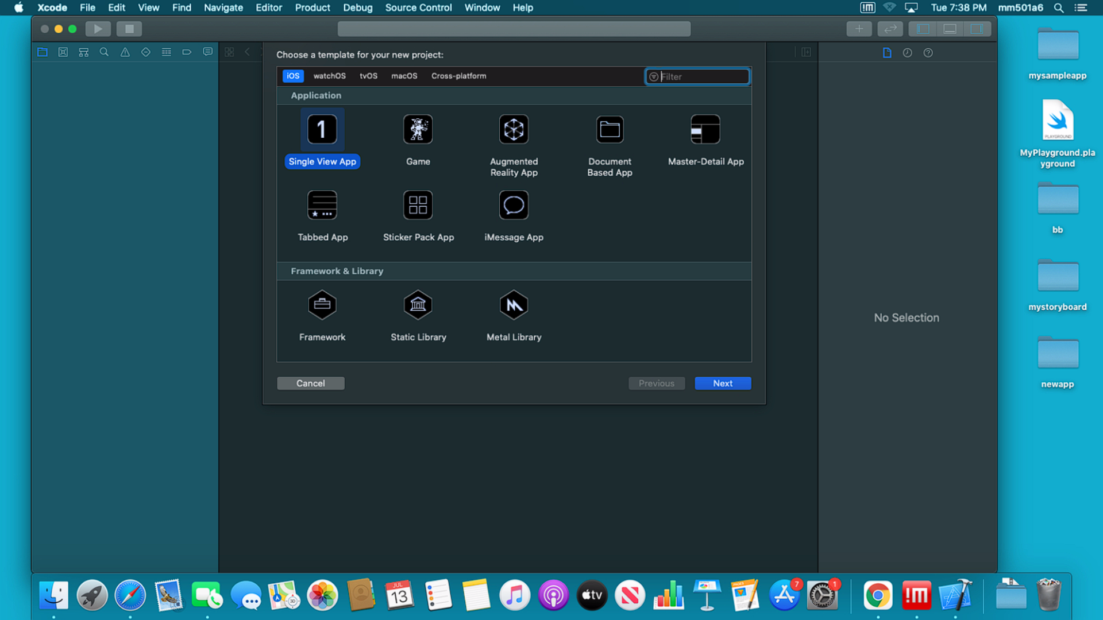

* **Selecting the new project details**

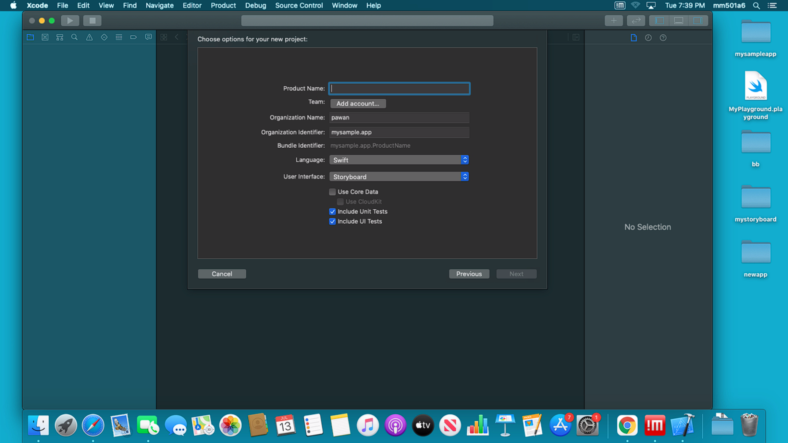

* **Choose project location**

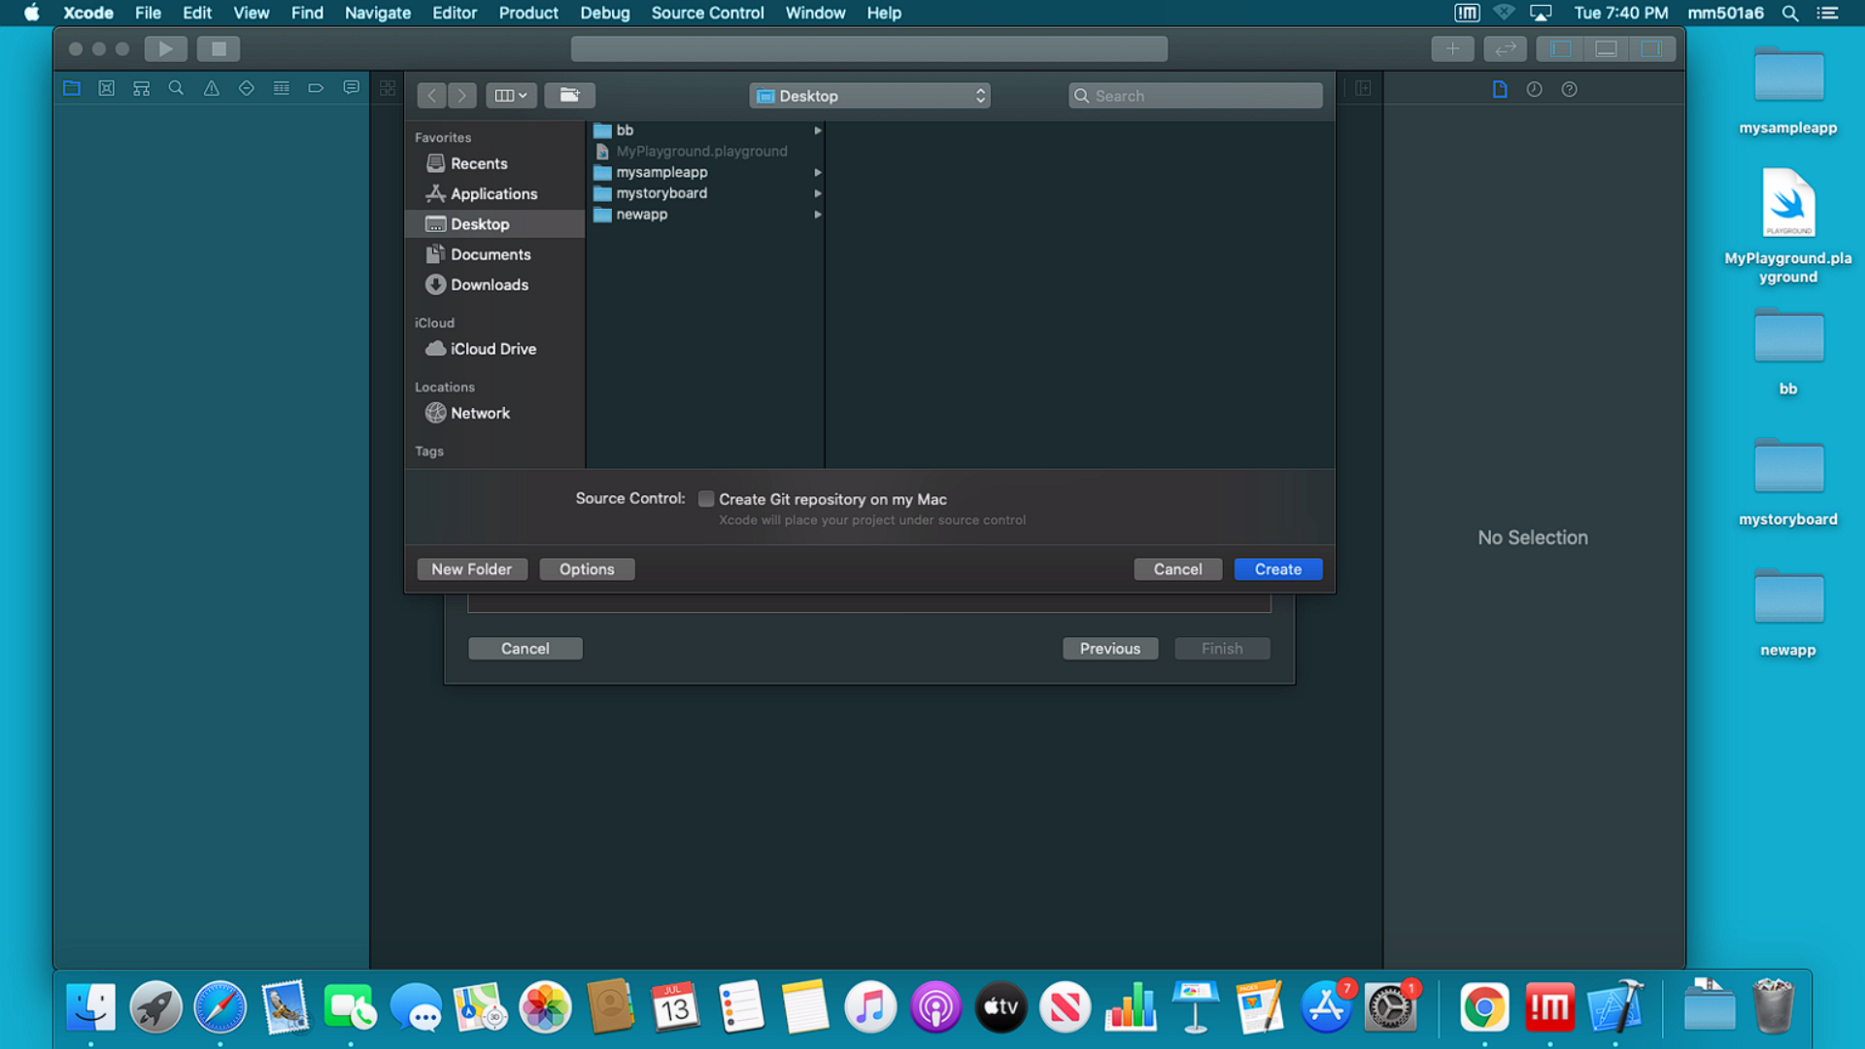

**Overview of Workspace**

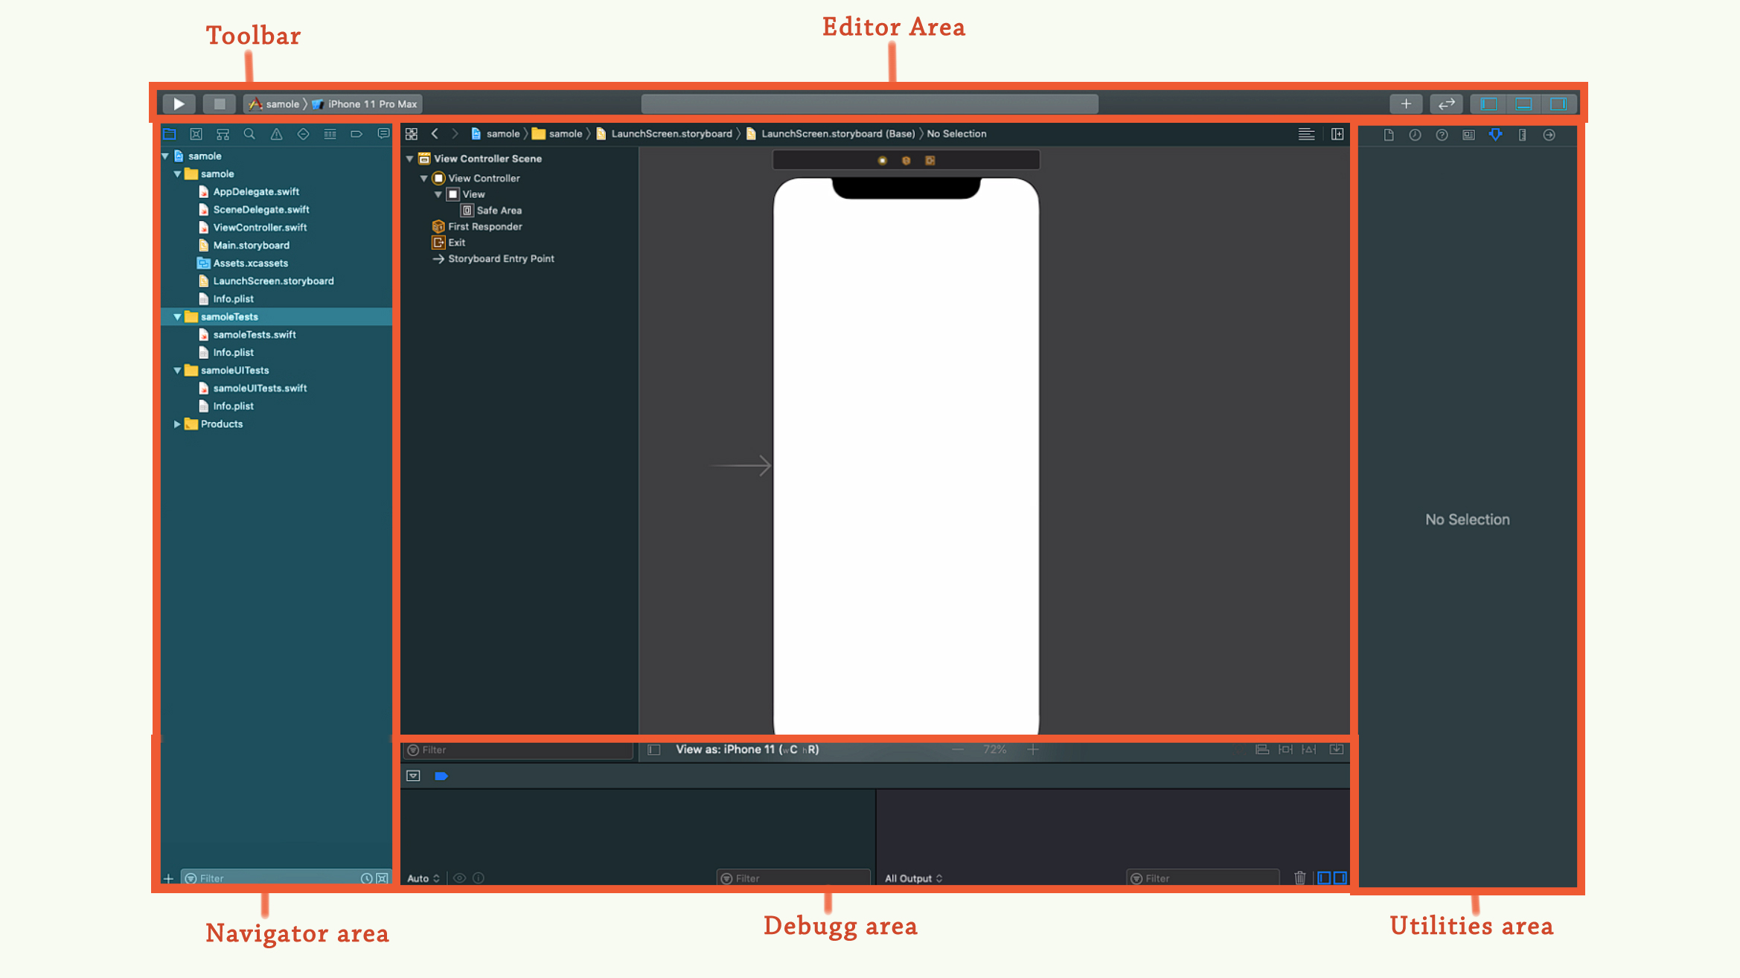

* **the navigator area**

this area is used for navigating all facets of your project, including files, symbols, breakpoints, build issues, tests, breakpoints, and build reports. You can also search for any string in your project.

* **debug area**.

this area is used for viewing variables, interacting with the debugger console, and controlling the execution of your app

* **utilities Area**.

this area is used to inspect or modify attributes of files, graphical user interface elements, sprites, and other elements in your project. Also use it to access a library of ready-made resources.

**Xcode as a simulator**

After creating a project, we can build and run your app on a simulated. Launch your app in a simulated iOS, tvOS, or watchOS device

For iOS, tvOS, and watchOS apps, you can choose a simulated device, under [Platform] Simulators, from the run destination menu next to the scheme menu in the toolbar.

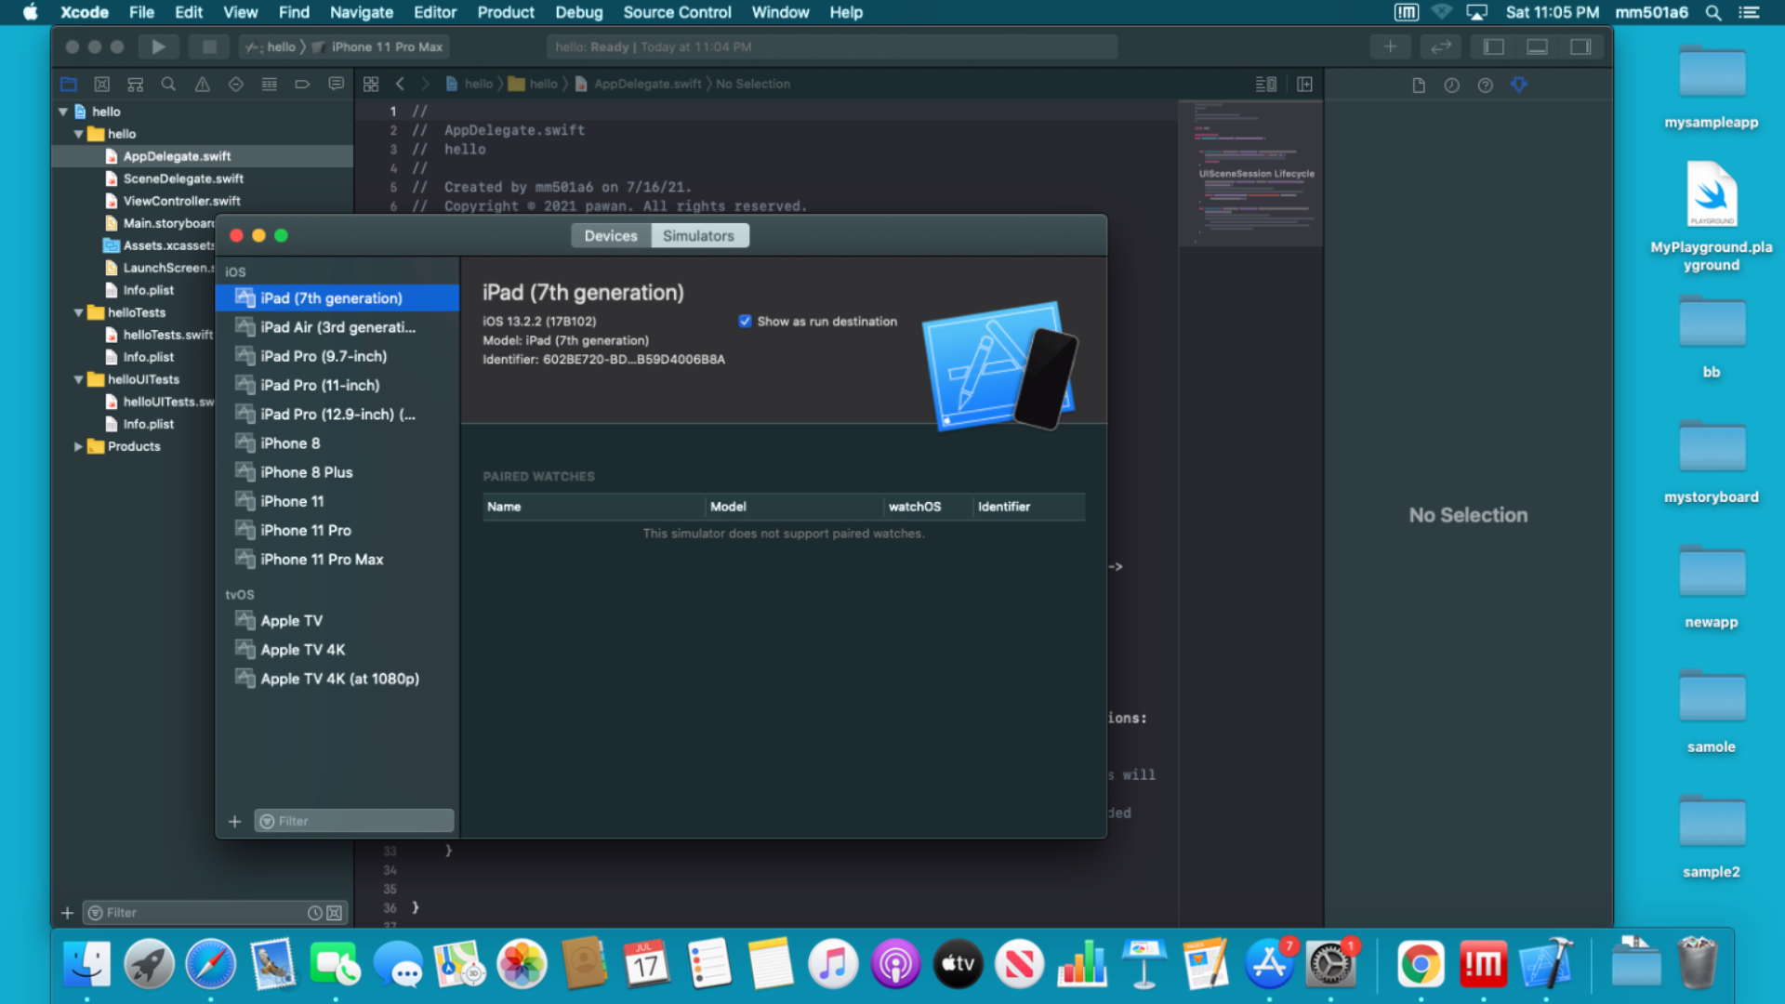

**Customizing the Editor**

**Syntax-Aware Fonts and Text Colors:** Xcode assigns a color and font to each syntactic type to make it easier for you to read the code. we can select from several font and color themes by choosing Xcode > Preferences and then selecting Fonts & Colors.

**Xcode ide features**

* **Source Editor:** Write code using a professional editor with advanced code completion, code folding, syntax highlighting, and message bubbles that display warning, errors, and other context-sensitive information inline with your code.
* **Assistant Editor:** The Assistant button splits the editor in two, creating a secondary pane that automatically displays files that are most helpful to you based on the code you are actively editing.
* **Compilers:** The powerful open-source LLVM compiler for C, C++, and Objective-C is built into Xcode and available from Terminal. With it, your code compiles quickly, and is optimized by Apple to produce blazing-fast apps specifically tuned for the CPUs in iPhone, iPad, and Mac.
* **Interface Builder Built-In**: Design and test your user interface without writing a line of code, prototype in minutes, then graphically connect your interface to the source within the Xcode editor.
* **Live Issues**

Just like a word processor highlights spelling errors, Live Issues highlights common coding mistakes, without the need to click ‘build’ first.

* **Fix-it:** Xcode goes beyond just reporting errors. When you make a coding mistake, Xcode will immediately alert you, and a single keyboard shortcut will instantly fix the issue

**References**: <https://developer.apple.com/xcode>

Apple developer documentation.